

**Modern Problems, Modern Solutions**

**12B Greenway Avenue, Lincoln LN2 1PH, UK**

**Wright Consultancy**

26th October 2017

Ms. P. Power   
Power Printing Ltd

Main Road  
Cenchester

Dear Ms. Power,

We hope this letter finds you well. Thank you for taking the time to meet with us on Tuesday morning. We have since received your letter outlining the economics of pulping which will be most beneficial to us going forward.

Below are two aspects we would like to reiterate with you:

* We spoke about the potentially significant increase in book size due to translation from English to other European languages. This will lead to an increase in the average page count of the QNF series by approximately 25% and as a result the £9 per book offering from Pulp should be adjusted.
* We also gathered that all current projects must not be hindered throughout this potential expansion; however, the current floor space may be reorganised and we have since discussed this further with Len. Should you feel anything to the contrary please let us know.
* You also mentioned that you will source some quotes for costs of raw materials (paper, ink, etc.). Please keep us updated and let us know if we can assist in any way.

If you have any further comments, please do not hesitate to reach out to us and we look forward to meeting with you again in the near future.

Yours sincerely,

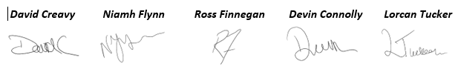**Team 5**